**Hardware components(28/feb/2022)**

**Input Unit:(Keyboard, mouse)**

An input device is a something you connect to a computer that sends information to the computer.

**Examples:**

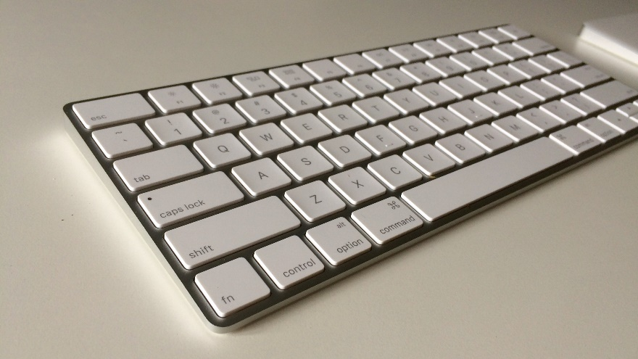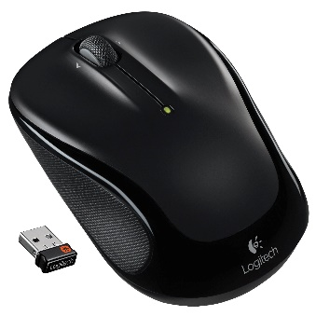

**Output Unit:(Monitor, printer)**

An output device is a something you connect to a computer that has information send to it.

**Examples:**

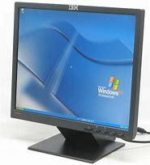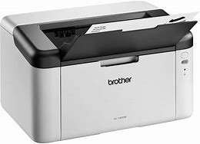

**Memory unit:(Harddisk)**

It is a component of a computer system.it is used to store data, instructions and information.

**Example:**

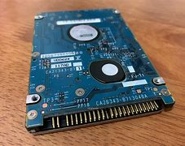

**ALU:(Arithmetic and logical unit)**

It is a part of CPU that carries out arithmetic and logical operations.

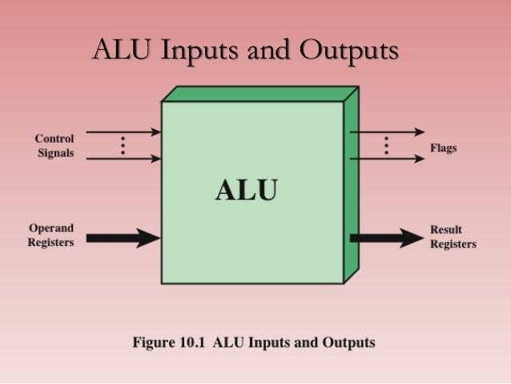

**CPU:(Central processing unit)**

CPU is a portion of computer that retrieves and executes information. It consists of an ALU &CU.

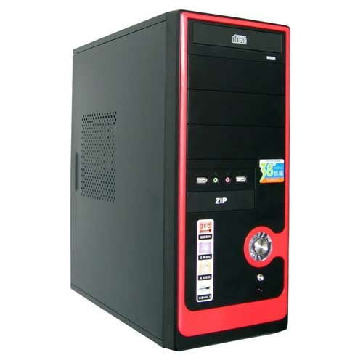

**Write a pseudocode and flowchart for greatest of three numbers:**

**Pseudocode**

Step 1: Start

Step 2:Declare variables n1,n2,n3

Step 3:if n1 is greater than n2,

If n1 is greater than n3,

Display n1 is maximum

Else

Display n3 is maximum

Else

If n2 is greater than n3,

Display n2 is maximum

Else

Display n3 is maximum

Step 4: Stop

**Flowchart:**

